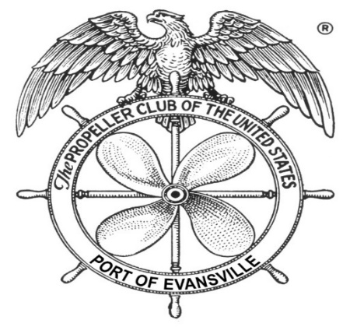
International Propeller Club of the United States – Port of Evansville, IN – Port #164
2019 Newsletter

December 27, 2019

On behalf of the International Propeller Club – Port of Evansville, IN (Port #164) Board of Directors, we would like to thank everyone for the continued support in 2019. Our club of 41 years is very fortunate that we continue to have strong corporate support and people willing to support the Maritime industry. The following information hopefully shares a few of the 2019 accomplishments along with some of the areas that remain a focus as we transition into 2020.
2019 Board Members (22 years of average membership)
Position | Member | Company | Years of Club / Board Support
President | Mickey Hammers | Traylor Bros., Inc. | 9+ / 6
Vice Pres. | Denise Clark | Ohio Valley Marine | 14 / 4
Past Pres. | Jeff McCutchan | Air Gas | 23 / 21
Treasurer & Secretary | Katie Riecken | Inland Marina | 10 / 10
2016 Gov. | Ron Riecken | Inland Marina | 41 / 41
2016 Gov. | Roy Adams | Daviess County Sand & Gravel | 41 / 41
2017 Gov. | Alan Fleischmann | Corn Island Shipyard | 20 / 2.5
2017 Gov. | Jay Gilbert | Bunge | 19 / 8
2017 Gov. | Mike Kilgore | Retired from Cummins | 28 / 22
2017 Gov. | Greg Minnette | Fulcrum Lifting (Vernon Corporation) | 24 / 22
2018 Gov. | Ron Kolb | Compass Marine | 24 / 18
2018 Gov. | Jimbo Clark | Evansville Marine Service | 11 / 1.5
2018 Gov. | Jeff Hamilton | Yager Marine | 19 / 5
Important to note that Ron Riecken was one of our founding members and Roy Adams joined soon after the club was established.

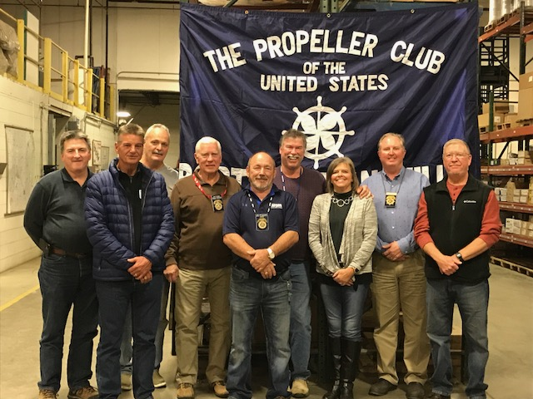
2019 Board Members from Left to Right – Jeff Hamilton, Roy Adams, Ron Kolb, Mike Kilgore, Jeff McCutchan, Jimbo Clark, Denise Clark, Mickey Hammers, and Greg Minnette

Missing are Alan Fleischmann, Ron Riecken, Katie Riecken, and Jay Gilbert
Investigate ways to grow membership – Membership is a growing concern for all types of clubs, including the International Propeller Club. Each Port must provide the total number of paid members in January of each year. The January 2019 numbers represent an 11.6% decrease on the International level, 3.5% increase on the Regional level, and an 8% decrease on the local level. We are hopeful that with your support and communication the membership in 2020 will rebound. It’s important to get your dues paid promptly.
  - 2019 Incentive to bring a guest was a chance to win $200.
    - Jeff Hamilton of Yager Marine was the lucky winner.
  - Investigate utilizing Facebook, Twitter, and other social media tools to help promote the club and our goals
    - This is still a topic of discussion as we move into 2020.
  - Move Maritime Day celebrations to various locations to bring awareness to the club.
    - 2019 Maritime Day was held at the convention center located in Owensboro, KY
Work to ensure we have quality monthly meetings with good attendance amongst members. – Goal is to ensure we have a good mix of social and educational meetings that provide value and interest to our members. 2019 had 64% of the meetings were educational, while 36% were social. Please help us by providing suggestions for topics that have interest to you and/or your company.
  - 2019 - Investigate new topics, speakers, and locations
    - Not counting the Golf outing 6 of the 10 meetings in 2019 had something new from 2018. See the red font items in the table below.
    - We have the January 8, 2020 meeting scheduled for the Evansville Boys and Girls Club – Hope to see everyone there.
  - The average monthly meeting attendance slipped to 31 in 2019. (2017 was 37 & 2018 was 43)
Corporate Sponsorships
A special thanks goes to the following that hosted a meeting in 2019 and those that help with providing Topics. It’s important to note that several of these companies have supported the club for many years and we look forward to their continued support.
Month | Hosted By | Topic | Location
January | Traylor Bros. | Mental Health within Construction | Archie & Clyde’s Newburgh, IN
February | Brandies | USCG update on Barges against McAlpine Dam in Louisville, KY | Brandies Evansville, IN
March | Whayne Supply | River Works Discovery | Car Museum Evansville, IN
April | Yager Marine | Facility Tours & Social | Reid’s Orchard Owensboro, KY
May | Mulzer | Corp. of Engineers Update | Mulzer Camp  Troy, IN
June | Evansville Marine Service | Golf Outing | Rolling Hills  Newburgh, IN
July | United Leasing | Discuss history of United Leasing and what they offer | Inland Marina  Evansville, IN
August | Owensboro Riverport | O.Z. Tyler Facility Tour | O.Z. Tyler  Owensboro, KY
September | Evansville Marine Service | USCG Update | EMS  Evansville, IN
October | Corn Island Shipyard | Facility Tours & Social | Corn Island  Grandview, IN
November | Air Gas | Vendor Rodeo | Air Gas  Evansville, IN
Red font indicates new for 2019
Continue focus on the Ohio Valley Region – Ports of Evansville, Paducah, Nashville, and Louisville aka “Brown Water” clubs to ensure growth of the Region and have a larger voice at the International meetings.
  - Opened communication channels and continue sharing of ideas for growth.
  - Discussions are to meet annually but strive to attend meetings of the other clubs and work towards a joint meeting in the future.
Work to support the USCG and Corp. of Engineers – As generations pass, people tend to take things for granite and fail to realize just how important the waterway system is to the safety and wellbeing of the United States. We as a Propeller Club feel proud to work with the USCG and Corp of Engineers to support their efforts and keep communications open to assist where possible.
  - Relationships continue to grow as we work towards common goals.
  - The Board Members voted to donate $5,000 towards the local United States Coast Guard during a time of need during a recent Government shutdown.

Fundraising and Corporate Support
Bob Aldrich and the EMS team provided yet another successful Joe Gagnon Memorial Golf Scramble at the Rolling Hills Country Club in June. This was the 32nd annual event and the weather and food could not have been better. As many of you know, this is the only fundraiser for our club, and we cannot express enough gratitude for the continued support from everyone.

Full Hole Corporate (Gold) Sponsor at $500 each
American Commercial Barge Line  Assured Partners / Steve Wilken  Digestive Care Center / Dr. Don Bailey  Evansville Marine Service  Evansville Welding Supply  German American Bank / Joh Lamb  Great Lakes Power Products | Heritage Petroleum  McNational Inc.  Mulzer Crushed Stone  Owensboro Riverport Authority  TIIMCO  Yager Materials  Western Rivers Boat Management
½ Hole Corporate (Silver) Sponsor at $250 each
Abco Industrial Supply  Compass Marine Services  Cummins Sales and Service  Daviess County Sand & Gravel  Inland Marina, Inc. | Paducah Rigging  Philly Strand  Rudd Equipment  Vernon Lifting
Corporate (Bronze) Sponsor at $150 each
Airgas  Diamond Equipment  Henderson County Riverport Authority | Traylor Bros., Inc.  Whayne Power Systems
Special Gifts
Cardinal Tickets – ADM
Golf Foursome at Rolling Hills – Rolling Hills / Brian Jones
Golf Foursome at Cambridge – Matt Scheessele
Golf Foursome at Victoria National – Dave Clement of Diamond Equipment
Indianapolis 500 tickets – The Vernon Corporation

2019 Recognitions & Acknowledgments

Russell Woosley
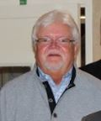
The club lost a longtime supporter and past Club President with the passing of Russell Woosley. For those that worked with Russel during his career, spoke highly of his efforts and dedication to the Maritime Industry. The club has placed his name on the Propeller Club monument located at Inland Marina. Prayers and thoughts go out to his family and friends.

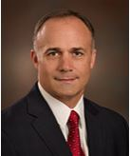
Maritime Person of the Year
Brian Wright (President/CEO) of the Owensboro Riverport Authority was voted as the Maritime Person of the year. Brian and his team continue to experience growth at the Owensboro Riverport, which benefits the entire region. Brian also resides on several boards and committees that further promote the Maritime Industry at the regional and national level. Some of which include the Inland Rivers & Ports Terminal Association, Kentucky Associations of Riverports and Transportation Advisory Committee, and Green River Area Development Regional Transportation Committee. Brian was appointed to a 2-year term by the United States Maritime Administration to the Maritime Transportation System National Advisory Committee (MTSNAC) in 2016 and reappointed in 2019. We are glad to have Brian as a member of our club and provide him a special thank you for his continued efforts within the Maritime Industry.

Port Person of the Year
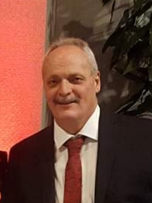
Ron Kolb (Owner) of Compass Marine, LLC was voted Port Person of the year. Ron has been a member of the club for 24 years and served on the Board of Directors for the past 18 years. Ron served as the Port President between 2011 and 2013 and was also part of the team that help host the 2014 International club meeting in Louisville, KY. Ron’s efforts to support the Maritime Industry and several of the Propeller Club Ports are much appreciated. For those that may not know, unless you attended the Shrimp Boil at the Airgas November meeting, Ron is a good cook as well. We are fortunate to have Ron in our club and appreciate his continued efforts. We also want to wish Ron and Diane many years of happiness as they were recently married.

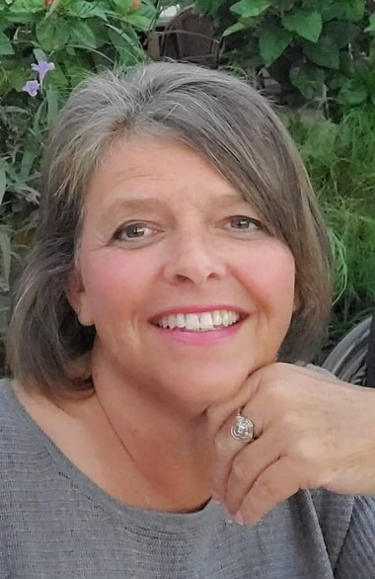
2020-2022 Port #164 President
Denise Clark of Ohio Valley Marine was voted Port President for the upcoming 2020 to 2022 term. Denise brings 14 years of club experience and 4 years of being on the Board of Directors. Denise has already shown she is willing to help out however necessary to ensure things continue to move forward and we stay focused on the challenges that lay ahead. The Board is excited and has confidence that she will help lead the Board of Directors and work to better the club. A congratulations also goes out to Denise, as she is the first female president in the history of the club.

2017-2019 Port #164 President Message
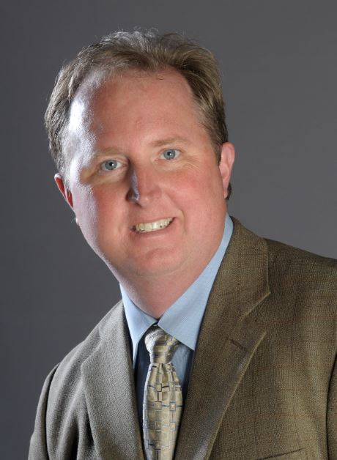
I would like to personally thank all those that provided support during my recent term as president. It has been an honor and privilege and I look forward to further supporting the club and Maritime Industry. The extra work and time invested has been a challenge at times, but I have grown personally as well as gained several relationships on a personal and professional level. I would encourage others to accept the challenge and participate at some level within the club, so you too have the opportunities to promote the Maritime Industry and develop friendships on a local, national, and/or international level.

As we prepare for 2020, your Board of Directors are working to establish some goals that continue to promote and grow our club. Attached is a proposed agenda as we know it today. As the meetings are finalized you will receive a notice via email and/or mail. We hope that you take a few minutes and mark your calendars in hopes that you can attend as many meetings as your schedule allows.

Special Thank You for 2019 and have a Happy New Year,
Your Board of Directors;
Mickey Hammers, Denise Clark, Jeff McCutchen, Katie Riecken, Roy Adams, Ron Riecken, Alan Fleischmann, Jay Gilbert, Mike Kilgore, Greg Minnette, Ron Kolb, Jimbo Clark, & Jeff Hamilton
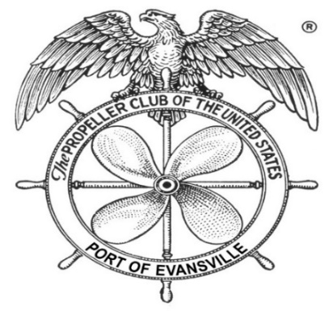
The US Propeller Club, Port of Evansville, Ind.
2020 Preliminary Monthly Club Meetings

Please note that notifications will be sent out as meeting dates and topics are confirmed.

January 8th – Evansville Boys and Girls Club / Evansville, IN
February 12th –
March 11th –
April 8th – Yager / Owensboro, KY
May 13th – Mulzer / Troy, IN – US Army Corp. of Engineers Update?
June 8th? – Newburgh, IN / Golf Outing
July 8th –
August 12th – Owensboro Riverport / Owensboro, KY
September 9th – EMS / Evansville, IN
October 14th – Corn Island / Grandview
November 11th –

